Prepared by:
NH Department of Environmental Services February 2023

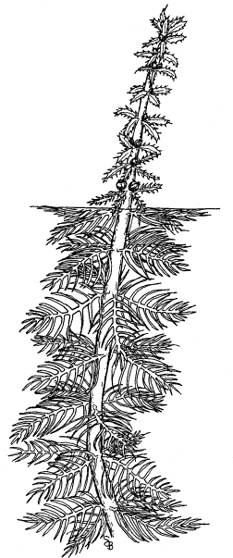
Long-Term Variable Milfoil Management Plan
. . . . . . . . . .

Lake Monomonac Rindge, New Hampshire

Page 2 of 54

Contents

Purpose 5
Invasive Aquatic Plant Overview 5
Variable Milfoil Infestation in Lake Monomonac 6
Milfoil Management Goals and Objectives 8
Local Support 9
Town or Municipality Support 9
Lake Monomonac Property Owners Association Support 9
Waterbody Characteristics 9
Beneficial (Designated) Uses of Waterbody 11
Aquatic Life 11
Recreational Uses and Access Points 12
Macrophyte Community Evaluation 13
Wells and Water Supplies 14
Historical Control Activities 14
Aquatic Invasive Plant Management Options 16
Feasibility Evaluation of Control Options in this Waterbody 17
Recommended Actions, Timeframes and Responsible Parties 18
Notes 22
Target Specificity 22
Adaptive Management 22
Figure 1: Map of Typical Areas of Variable Milfoil 23
Figure 2: Map of Control Actions Over Time 24
2007 24
2008 24
2009 25
2010 25
2011 26
2012 26
2013 27
2014 (actual) 28
2015 (actual) 29
2016 (actual) 30
2017 (actual) 31
2018 (Actual) 32
2019 Actual 33
2020 Actual 34
2021 Actual 35
2022 Actual 35
2023 Proposed 36
Figure 3: Map of Native Aquatic Macrophytes 38
Key to Macrophyte Map 39
Figure 4: Bathymetric Map 40
Figure 5: Critical Habitats or Conservation Areas 41
Figure 6: Public Access Sites, Swim Areas, Docks and Swim Platforms 42
Figure 7: Wells and Water Supplies 43
Appendix A Aquatic Plant Control Techniques 44
Appendix B Control Practices Used in New Hampshire 49
Restricted Use Areas and Fragment Barrier: 49
Hand-pulling: 49
Diver Assisted Suction Harvesting 50
Mechanical Harvesting 50
Page 4 of 54
Benthic Barriers 51
Targeted Application of Herbicides 51
Extended Drawdown 52
Dredging 53
Biological Control 53
References 54

Purpose

The purposes of this exotic aquatic plant management and control plan are:

- To identify and describe the historic and current exotic aquatic infestation(s) in the waterbody;
- To identify short-term and long-term exotic aquatic plant control goals;
- To minimize any adverse effects of exotic aquatic plant management strategies on non-target species;
- To recommend exotic plant control actions that meet the goals outlined in this plan; and
- To evaluate control practices used in this waterbody over time to determine if they are meeting the goals outlined in this plan.

This plan also summarizes the current physical, biological, ecological, and chemical components of the subject waterbody as they may relate to both the exotic plant infestation and recommended control actions, and the potential social, recreational and ecological impacts of the exotic plant infestation.

The intent of this plan is to establish an adaptive management strategy for the long-term control of the target species (in this case variable milfoil) in the subject waterbody, using an integrated plant management approach.

Appendix A and Appendix B detail the general best management practices and strategies available for waterbodies with exotic species, and provide more information on each of the activities that are recommended within this plan.

Invasive Aquatic Plant Overview

Exotic aquatic plants pose a threat to the ecological, aesthetic, recreational, and economic values of lakes and ponds (Luken & Thieret, 1997, Halstead, 2000), primarily by forming dense growths or monocultures in critical areas of waterbodies that are important for aquatic habitat and/or recreational use. Under some circumstances, dense growths and near monotypic stands of invasive aquatic plants can result, having the potential to reduce overall species diversity in both plant and animal species, and can alter water chemistry and aquatic habitat structure that is native to the system.

Page 6 of 54

Since January 1, 1998, the sale, distribution, importation, propagation, transportation, and introduction of key exotic aquatic plants have been prohibited (RSA 487:16-a) in New Hampshire. This law was designed as a tool for lake managers to help prevent the spread of nuisance aquatic plants.
New Hampshire lists 27 exotic aquatic plant species as prohibited in the state (per Env-Wq 1303.02) due to their documented and potential threat to surface waters of the state.

According to the federal Section 305(b) and 303(d) Consolidated Assessment and Listing Methodology (CALM), “exotic macrophytes are non-native, fast growing aquatic plants, which can quickly dominate and choke out native aquatic plant growth in the surface water. Such infestations are in violation of New Hampshire regulation Env-Wq 1703.19, which states that surface waters shall support and maintain a balanced, integrated and adaptive community of organisms having a species composition, diversity, and functional organization comparable to that of similar natural habitats of a region” (DES, 2006). In fact, waterbodies that contain even a single exotic aquatic plant do not attain water quality standards and are listed as impaired.

Variable Milfoil Infestation in Lake Monomonac

Lake Monomonac is a border lake between New Hampshire and Massachusetts. Variable milfoil (Myriophyllum heterophyllum) was documented in Monomonac Lake in Rindge, New Hampshire in the 1990s. The plant has colonized several small coves throughout the lake in both Massachusetts and New Hampshire.

The table below includes a summary of the general areas in Lake Monomonac that have supported milfoil growth over time, as shown in Figure 1. These areas only describe common and active areas of variable milfoil growth in the New Hampshire portion of Lake Monomonac. Milfoil is present in the Massachusetts portions of the lake as well, to varying degrees. The New Hampshire areas have been assigned site numbers that will be used to identify where various control activities will take place from year to year.

Subsequent maps that are included in this management plan will consistently reference the assigned site numbers when control practices are performed in those areas, adding new sites as appropriate. It can be expected that in some years some sites will not require treatment, while others will. The lake association works with the contractor to determine final treatment areas

each year, and generally not more than 10 acres of treatment are performed in the waterbody on the New Hampshire side each year.

Area (label varies among  maps) | Location/Area Description | Description of Growth
1 (A) | Area 1 is in a small cove on the western side of the lake. The cove is relatively narrow and shallow. There is a public access point to the lake located  in this cove. | Variable milfoil growth has been moderate to abundant over time.  2022- No growth observed
2 (B) | Area 2 is an embayment area on the lake, located on the western shoreline. | Variable milfoil has been moderately abundant along a section of shoreline extending down the point.  2022- No growth observed
3 (C) | Area 3 is located on the western shoreline of the lake behind a series of small to large islands. It is to the west of  Paradise Island. | Variable milfoil commonly grows in this area and often requires management.  2022- No growth observed
4 (D) | Area 4 is to the east of Paradise Island. | This is another area of common (regular) milfoil growth in Lake Monomonac.  2022- No growth observed
5 (E) | Area 5 is located on the eastern side of a point of land along the northwestern shoreline. This area is relatively exposed to the main body of the lake, though there are some small islands  scattered throughout the area. | Milfoil grows between the islands and the mainland.  2022- A couple of stems of milfoil observed
6 (F) | Area 6 is located at the northern end of Coot Bay, on the northwestern side of Lake Monomonac. | The variable milfoil in this area is very dense throughout much of this 5 acre area.  2022- A couple of stems of milfoil observed.
7 (H) | Area 7 is located in the cove to the east of Swan Point. | Variable milfoil growth has been common in this area, and is often present as small to large-sized patches in the northern end of the cove.  2022- Patchy areas of milfoil observed pre-treatment. None post-treatment.

Page 8 of 54

Area (label varies among  maps) | Location/Area Description | Description of Growth
8 (I) | Area 8 is a small cove on the eastern side of the lake, just north of the NH/MA state border. | Variable milfoil has been present in small to medium patches in this area.  2022- No growth observed
9 (G) | Area 9 is located at the northern end of the lake, and includes several small coves and bays, and portions of the inlet stream feeding in to the lake. | Variable milfoil growth is common in this area, and can be abundant in the back portions of the coves where it has flowered regularly when it tops out. Some of these areas are quite shallow and diving would be limited.  2022- Patchy areas of milfoil growth observed pre-treatment, none post  treatment.
10 (H) | Area 10 is a small backwater cove to the east of the beach. The backwater is fairly shallow (<5 feet), with a narrow/shallow restricted opening to the lake. | Variable milfoil growth was reported in this area in 2021 by local lake residents, and confirmed by NHDES.  2022- Patchy variable milfoil growth  observed early in 2022, none documented post treatment.

In terms of the impacts of the variable milfoil in the system, there are several (500+) houses around the shoreline of Monomonac Lake, with mostly seasonal cottages, though there are a few year-round dwellings. Approximately half of those houses are on the New Hampshire side of the border. There are no back lots with lake rights.

Impacts to shorefront residents are seen mainly in areas abutting thick growth, and include swim impairments, boating and navigation impairments, and fouling of swim beaches.

Milfoil Management Goals and Objectives

The goal for Lake Monomonac is the reduction of overall biomass and distribution of variable milfoil in the system. Generally small cove areas and small shoreline segments are targeted for management, where there are higher population densities (and thus use of the shoreline for recreational activities).

Local Support

Town or Municipality Support
The town of Rindge has not allocated funds for milfoil control, all activities are done through the lake association.

Lake Monomonac Property Owners Association Support
The MLPOA is strongly behind controlling growths of variable milfoil in Lake Monomonac. The lake also has an active Lake Host Program during the summer months, and they also monitor water quality of the lake.

Waterbody Characteristics

The following table summarizes basic physical and biological characteristics of Lake Monomonac, including the variable milfoil infestation. Note that a current review of the Natural Heritage Bureau (NHB) database was requested and the results from that are pending. NHB data referenced in this plan are based on data from historic reviews.

Page 10 of 54

Parameter/Measure | Value/Description
Lake area (acres) | 711.1
Watershed area  (acres) | 12,488.4
Shoreline Uses (residential, forested,  agriculture) | Residential, forested
Max Depth (ft) | 25.6
Mean Depth (ft) | 9.2
Trophic Status | Mesotrophic
Color (CPU) in Epilimnion | 45
Clarity (ft) | 8.9
Flushing Rate (yr-1) | 3.60
Natural  waterbody/Raised by Damming/Other | Raised by damming
Invasive Plants (Latin  name) | Variable milfoil (Myriophyllum heterophyllum)
Infested Area (acres) | See figures
Distribution (ringing lake, patchy growth,  etc) | See figures
Sediment type in infested area (sand/silt/organic/rock  ) | Organic/rocky/silty
Rare, Threatened, or Endangered Species in Waterbody (according to NH Natural Heritage Bureau (NHB)  Inventory review) | 2023 Listed Species: Banded Sunfish (Enneacanthus obesus) Blanding's Turtle (Emydoidea blandingii)  Additional Historically Listed Species: Ebony Boghaunter (Williamsonia fletcheri)

A native aquatic vegetation map and key by the NHDES Biology Section is shown in Figure 3 (checked periodically for accuracy). A bathymetric map is shown in Figure 4.

Beneficial (Designated) Uses of Waterbody

In New Hampshire, beneficial (designated) uses of our waterbodies are categorized into five general categories: Aquatic Life, Fish Consumption, Recreation, Drinking Water Supply, and Wildlife (CALM).

Of these, Aquatic Life, Wildlife and Recreation are the ones most often affected by the presence of invasive plants, though drinking water supplies can also be affected as well in a number of ways.

Following is a general discussion of the most potentially impacted designated uses, including water supplies and near shore wells, as they relate to this system and the actions proposed in this long-term plan.

The goal for aquatic life support is to provide suitable chemical and physical conditions for supporting a balanced, integrated and adaptive community of aquatic organisms having a species composition, diversity, and functional organization comparable to that of similar natural habitats of the region.

Aquatic Life
Fisheries Information
According to the NH Fish and Game Department, Lake Monomonac is managed as a warmwater fishery. Largemouth and small mouth bass are the primary gamefish present. Largemouth bass growth was categorized as fast when compared to fish from New Hampshire waterbodies sampled during 1997-2005 by Fish and Game. Average length at age was above statewide values (1997-2005) for all ages of largemouth bass from age 1-5.

Other species present include yellow perch, chain pickerel, golden shiner, pumpkinseed, white perch, creek chubsucker, brown and yellow bullhead, and black crappie.

The local Conservation Officer reports boat traffic to be extremely heavy, angling pressure is relatively light and anglers are generally pleased with their fishing success. A good number of bass tournaments are held on the

Page 12 of 54

lake each year and the lake is a popular destination for open water and ice anglers.

According to the 2019 historic review by the Natural Heritage Bureau (NHB), there is one fish species tracked in their records for Lake Monomonac, the banded sunfish (Enneacanthus obesus). There are no designations for the banded sunfish in New Hampshire but it is listed as a “species of concern” because it is rare or uncommon in the state. This species needs good mixed stands of aquatic vegetation for habitat. There are several stands of bladderwort, native milfoil and water marigold throughout the lake that can provide good submersed habitat for aquatic life. The banded sunfish record is from 20016.

Wildlife Information
According to historic NHB records, Blanding’s turtle is listed as endangered in New Hampshire, where it is rare or uncommon. It has no federal listing, and it is listed as globally secure, but a cause for concern. The NHB record is from 2006 when one adult turtle was observed. Blanding’s Turtles are mostly aquatic and are found in the shallows of lakes and ponds, in marshes, bogs, and small streams. The turtles nest on land, but feed underwater on insects, tadpoles, crayfish, and snails, among other small aquatic organisms. The Fish and Game Department requests that contractors avoid direct herbicide application in scrub shrub dominated wetland coves, in order to minimize impacts to this species.

The Ebony Boghaunter (Williamsonia fletcheri) was also included in the results of the NHB review for 2014. The ebony boghaunter is a species of concern in New Hampshire due to it’s rarity. It is not listed federally, and it is apparently secure, but with some cause for concern. This species was observed in Converse Meadow Pond, north of Lake Monomonac.

There are no NH F&G Wildlife Management Areas within a mile of this waterbody, or other known conservation lands abutting this waterbody. No species are being managed in this area currently.

Recreational Uses and Access Points
Lake Monomonac is used for numerous recreational activities, including boating, fishing, swimming, and water skiing by both pond residents and transient boaters.

There is one designated public access sites on Lake Monomonac, it is located on the southern end of the lake just off of Route 202 as one enters the State of Massachusetts.

There is one designated beach on Lake Monomonac, which is owned by Rindge Acres and it is a private beach. A designated beach is described in the CALM as an area on a waterbody that is operated for bathing, swimming, or other primary water contact by any municipality, governmental subdivision, public or private corporation, partnership, association, or educational institution, open to the public, members, guests, or students whether on a fee or free basis. Env-Wq 1102.14 further defines a designated beach as “a public bathing place that comprises an area on a water body and associated buildings and equipment, intended or used for bathing, swimming, or other primary water contact purposes. The term includes, but is not limited to, beaches or other swimming areas at hotels, motels, health facilities, water parks, condominium complexes, apartment complexes, youth recreation camps, public parks, and recreational campgrounds or camping parks as defined in RSA 216-I:1, VII. The term does not include any area on a water body which serves 3 or fewer living units and which is used only by the residents of the living units and their guests.

Roughly 10-20 people use the town beach during summer weekends. No data exist for weekday use.

Figure 6 shows the locations commonly used for swimming, and the locations of swim platforms and docks on Lake Monomonac, as well as the location of the access site. The tan colored polygons show locations where people generally use their waterfront areas and have private beach areas for swimming, and the red points show locations docks.

Macrophyte Community Evaluation

The littoral zone is defined as the nearshore areas of a waterbody where sunlight penetrates to the bottom sediments. The littoral zone is typically the zone of rooted macrophyte growth in a waterbody.

The littoral zone of Lake Monomonac is characterized by a mix of native and non-native (variable milfoil) plant growth (Figure 3). Native species include a mix of floating plants (white and yellow water-lilies, watershield), emergent plants (three-way sedge, pickerelweed, cattail, bur-reed), and submergent plants (various pondweeds, native milfoil, bladderwort). Native plant

Page 14 of 54

communities are mixed around the entire lake, and are characterized as ‘common to common/abundant’ by the DES, with higher abundances present in shallow cove areas.

An historic NHB review of the system revealed no state-listed endangered aquatic plants in Lake Monomonac.

Wells and Water Supplies

Figure 7 shows the location of wells, water supplies, well-head protection areas, and drinking water protection areas around the subject waterbody, based on information in the DES geographic information system records. Note that it is likely that Figure 7 does not show the location of all private wells.

Note that the map in Figure 7 cannot be provided on a finer scale than 1:48,000. Due to public water system security concerns, a large-scale map may be made available upon agreement with DES’ data security policy. Visit DES’ OneStop Web GIS, http://www2.des.state.nh.us/gis/onestop/ and register to Access Public Water Supply Data Layers. Registration includes agreement with general security provisions associated with public water supply data. Paper maps that include public water supply data may be provided at a larger-scale by DES’ Exotic Species Program after completing the registration process.

In the event that an herbicide treatment is needed for this waterbody, the applicator/contractor will provide more detailed information on the wells and water supplies within proximity to the treatment areas as required in the permit application process with the Division of Pesticide Control at the Department of Agriculture. It is beyond the scope of this plan to maintain updated well and water supply information other than that provided in Figure 7.

Historical Control Activities

SITE | DATE | METHOD | AREA (ac) | APPLICATOR
N/A | 7/13/1905 | NONE | N/A | N/A
VALASCO & COOT BAYS | 6/8/1999 | DIQUAT | 4 | ACT
VALAS, COOT, MARINA | 6/14/2000 | DIQUAT | 8 | ACT

SITE | DATE | METHOD | AREA (ac) | APPLICATOR
COOT & VALASCO BAYS | 6/6/2001 | DIQUAT | 5 | ACT
MTPL SITES | 6/25/2002 | DIQUAT | 8 | ACT
4 SITES | 6/17/2003 | DIQUAT | 3 | ACT
MTPL SITES | 6/9/2004 | DIQUAT | 5 | LYCOTT
MTPL SITES | 6/14/2005 | DIQUAT | 10 | ACT
7 SITES | 6/14/2006 | DIQUAT | 8.5 | ACT
4 SITES | 6/14/2007 | DIQUAT | 7 | ACT
8 SITES | 6/9/2008 | DIQUAT | 7 | ACT
VARIED | SUMMER 2008 | HAND PULL | VARIED | LOCAL DIVERS
MTPL SITES | 6/15/2009 | DIQUAT | 10 | ACT
VARIED | SUMMER 2009 | HAND PULL | VARIED | LOCAL DIVERS
MTPL SITES | 6/17/2010 | 2,4-D | 8 | ACT
MTPL SITES | 6/15/2011 | 2,4-D (100 LBS/ACRE  GRANULAR) | 7 | ACT
MTPL SITES | 6/28/2012 | 2,4-D (G) at 100  lbs/acre | 10 | ACT
MTPL SITES | 6/10/2013 | 2,4-D (G) at 131 LBS/AC | 10 | ACT
MTPL SITES | 6/11/2014 | DIQUAT 60 GALLONS | 30 ACRES | ACT
NORTHERN PORTIONS | 6/8/2015 | DIQUAT | 20.8  ACRES | ACT
6 SITES | 6/6/2016 | DIQUAT 54.8 GALLONS | 27.4  ACRES | SOLITUDE LAKE MANAGEMENT
SEE MAPS | 6/8/2017 | DIQUAT, 50 GALLONS | 25 ACRES | SOLITUDE LAKE MANAGEMENT
SEE MAPS | 6/7/2018 | DIQUAT, 50 GALLONS | 25 ACRES | SOLITUDE LAKE MANAGEMENT

Page 16 of 54

SITE | DATE | METHOD | AREA (ac) | APPLICATOR
SEE MAPS | 6/10/2019 | Tribune (Diquat) | 25 ACRES | SOLITUDE  LAKE MANAGEMENT
SEE MAPS | 6/8/2020 | PROCELLACOR | 3.6 ACRES | SOLITUDE LAKE  MANAGEMENT
SEE MAPS | 6/15/2022 | DIVER/DASH | 2.5  GALLONS | SARAH MACNEILAGE  PATEY, JAIME BURLEIGH
SEE MAPS | 6/16/2022 | PROCELLACOR | 7.0 ACRES | SOLITUDE  LAKE MANAGEMENT

There were no non-chemical (diving, DASH, or benthic barrier) activities performed on Lake Monomonac in recent years according to the lake association. DES continues to recommend that the lake association seek a contract with a diver/dive contractor to perform hand harvesting activities in areas of lower density variable milfoil growth, to minimize the need for herbicide treatment or increase the timespan between treatments.

Aquatic Invasive Plant Management Options

The control practices used should be as specific to the target species as feasible. No control of native aquatic plants is intended.

Exotic aquatic plant management relies on a combination of proven methods that control exotic plant infestations, including physical control, chemical control, biological controls (where they exist), and habitat manipulation.

Integrated Pest Management Strategies (IPM) are typically implemented using Best Management Practices (BMPs) based on site-specific conditions so as to maximize the long-term effectiveness of control strategies. Descriptions for the control activities are closely modeled after those prescribed by the Aquatic Ecosystem Restoration Foundation (AERF) (2004). This publication can be found online at http://www.aquatics.org/bmp.html.

Criteria for the selection of control techniques are presented in Appendix A. Appendix B includes a summary of the exotic aquatic plant control practices currently used by the State of New Hampshire.

Feasibility Evaluation of Control Options in this Waterbody

DES has evaluated the feasibility of potential control practices on the subject waterbody. The following table summarizes DES’ control strategy recommendations for the subject waterbody:

Control Method | Use on Lake Monomonac
Restricted Use Areas (RUAs) and/or Fragment Barriers | The purpose of RUAs and fragment barriers is to contain small areas of exotic aquatic plant growth to prevent them from spreading further in a system.  If variable milfoil is reduced by other integrated approaches outlined in this plan, then RUAs and fragment barriers may be a future consideration based on the size, configuration and location of  remaining areas of growth.
Hand-pulling | Recommended as a primary means of control for smaller/less dense areas of growth. DES recommends that the MLPOA hire a diver on retainer to perform monthly (2-3 days per month, as needed) dive activities during the growing season, to reduce their reliance on the use of herbicide as a primary control technique in Monomonac. Routine diving will reduce the likelihood that milfoil will rebound quickly in cove areas and other areas of the waterbody.  A list of certified Weed Control Divers can be found at www.des.nh.gov (click on the Program list, then under Water Diver click on Exotic Species Program link).
Mechanical Harvesting/Removal | Not recommended due to the risk of fragmentation  and drift, and subsequent further spread of the invasive plant.
Benthic Barriers | Recommended for small patches that are 20’ x 20’ in  size or less, and where practical.
Herbicides | Herbicide treatment is recommended as a primary means of control only where infestations of the exotic plant are too widespread and/or dense for  non-chemical means of control to be effective.
Extended  Drawdown | This waterbody draws down annually in the fall.  Drawdown is not an effective control technique in

Page 18 of 54

Control Method | Use on Lake Monomonac
 | the long-term for variable milfoil.
Dredge | Cost prohibitive and not often effective for  controlling invasive aquatic plants.
Biological Control | No biological controls are yet approved for use on  variable milfoil.
No Control | A no control option would only allow for further  spread of this plant within this border lake.

Recommended Actions, Timeframes and Responsible Parties

An evaluation of the size, location, and type of variable milfoil infestation, as well as the waterbody uses was conducted at the end of the last growing season (see attached figures for findings). Based on this survey the following recommendations are made for variable milfoil control in the system:

Year | Action | Responsible  Party | Schedule
2022 | Weed Watching and | Local Weed | Once a
 | marking/reporting of milfoil growth | Watchers | month
 |  |  | from May
 |  |  | through
 |  |  | September
 | Survey and planning for | NHDES | May/June
 | summer/fall milfoil control actions
 | Diving is recommended in areas of | Contract Diver | June-
 | lower density growth, and |  | September
 | following herbicide treatment to |  | as needed
 | prevent regrowth from expanding.
 | It will help to reduce herbicide
 | treatments in the long-term.

Year | Action | Responsible  Party | Schedule
 | Herbicide treatment, if needed, based on diver progress as monitored by DES (areas to be determined based on updated spring survey). Area 7 and 9 will need treatment in 2022, though additional sites may be added within previously documented zones of growth, based on spring  2022 surveys. | SŌLitude Lake Management, LLC. | June or September
 | Survey waterbody and planning for  next season’s control actions | NHDES | September
2023 | Weed Watching and marking/reporting of milfoil growth | Local Weed Watchers | Once a month from May through  September
 | Survey and planning for  summer/fall milfoil control actions | NHDES | May/June
 | Diving is recommended in areas of lower density growth, and following herbicide treatment to prevent regrowth from expanding. It will help to reduce herbicide  treatments in the long-term. | Contract Diver | June- September as needed
 | Herbicide treatment, if needed, based on diver progress as monitored by DES (areas to be determined based on updated  spring survey) | SŌLitude Lake Management, LLC. | Late spring or early fall
 | Survey waterbody and planning for  next season’s control actions | NHDES | September
2024 | Weed Watching and marking/reporting of milfoil growth | Local Weed Watchers | Once a month from May through  September

Page 20 of 54

Year | Action | Responsible  Party | Schedule
 | Survey and planning for  summer/fall milfoil control actions | NHDES | May/June
 | Diving is recommended in areas of lower density growth, and following herbicide treatment to prevent regrowth from expanding. It will help to reduce herbicide  treatments in the long-term. | Contract Diver | June- September as needed
 | Herbicide treatment, if needed, based on diver progress as monitored by DES (areas to be determined based on updated  spring survey) | SŌLitude Lake Management, LLC. | Late spring or early fall
 | Survey waterbody and planning for  next season’s control actions | NHDES | September
2025 | Weed Watching and marking/reporting of milfoil growth | Local Weed Watchers | Once a month from May through  September
 | Survey and planning for  summer/fall milfoil control actions | NHDES | May/June
 | Diving is recommended in areas of lower density growth, and following herbicide treatment to prevent regrowth from expanding. It will help to reduce herbicide  treatments in the long-term. | Contract Diver | June- September as needed
 | Herbicide treatment, if needed, based on diver progress as monitored by DES (areas to be determined based on updated  spring survey) | SŌLitude Lake Management, LLC. | Late spring or early fall
 | Survey waterbody and planning for  next season’s control actions | NHDES | September

Year | Action | Responsible  Party | Schedule
2026 | Weed Watching and marking/reporting of milfoil growth | Local Weed Watchers | Once a month from May through  September
 | Survey and planning for  summer/fall milfoil control actions | NHDES | May/June
 | Diving is recommended in areas of lower density growth, and following herbicide treatment to prevent regrowth from expanding. It will help to reduce herbicide  treatments in the long-term. | Contract Diver | June- September as needed
 | Herbicide treatment, if needed, based on diver progress as monitored by DES (areas to be determined based on updated  spring survey) | SŌLitude Lake Management, LLC. | Late spring or early fall
 | Survey waterbody and planning for  next season’s control actions | NHDES | September
2027 | Update and revise Long-Term Variable Milfoil Control Plan | DES and  Interested Parties | Fall/ Winter

Page 22 of 54

Notes

Target Specificity
It is important to realize that aquatic herbicide applications are conducted in a specific and scientific manner. To the extent feasible, the permitting authority favors the use of selective herbicides that, where used appropriately, will control the target plant with little or no impact to non- target species, such that the ecological functions of native plants for habitat, lake ecology, and chemistry/biology will be maintained. Not all aquatic plants will be impacted as a result of an herbicide treatment.

Adaptive Management
Because this is a natural system that is being evaluated for management, it is impossible to accurately predict a management course over five years that could be heavily dependent on uncontrolled natural circumstances (weather patterns, temperature, adaptability of invasive species, etc).

This long-term plan is therefore based on the concept of adaptive management, where current field data (from field survey work using DES established field survey standard operating procedures) drive decision making, which may result in modifications to the recommended control actions and timeframes for control. As such, this management plan should be considered a dynamic document that is geared to the actual field conditions that present themselves in this waterbody.

If circumstances arise that require the modification of part or all of the recommendations herein, interested parties will be consulted for their input on revisions that may be needed to further the goal of variable milfoil management in the subject waterbody.

Figure 1: Map of Typical Areas of Variable Milfoil in Lake Monomonac

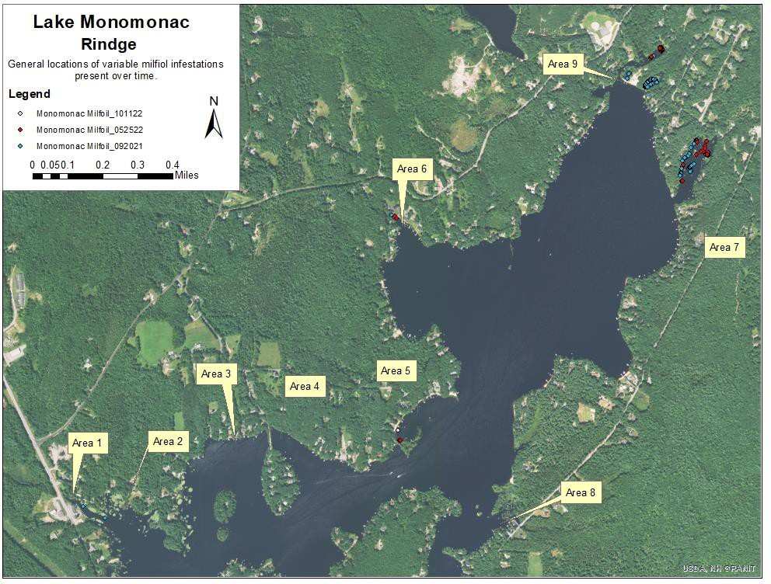

Page 24 of 54

Figure 2: Map of Control Actions Over Time

2007
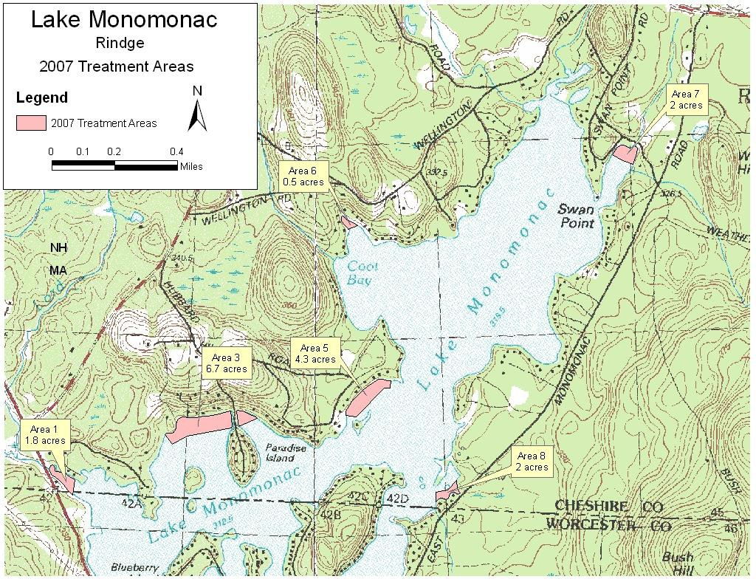

2008
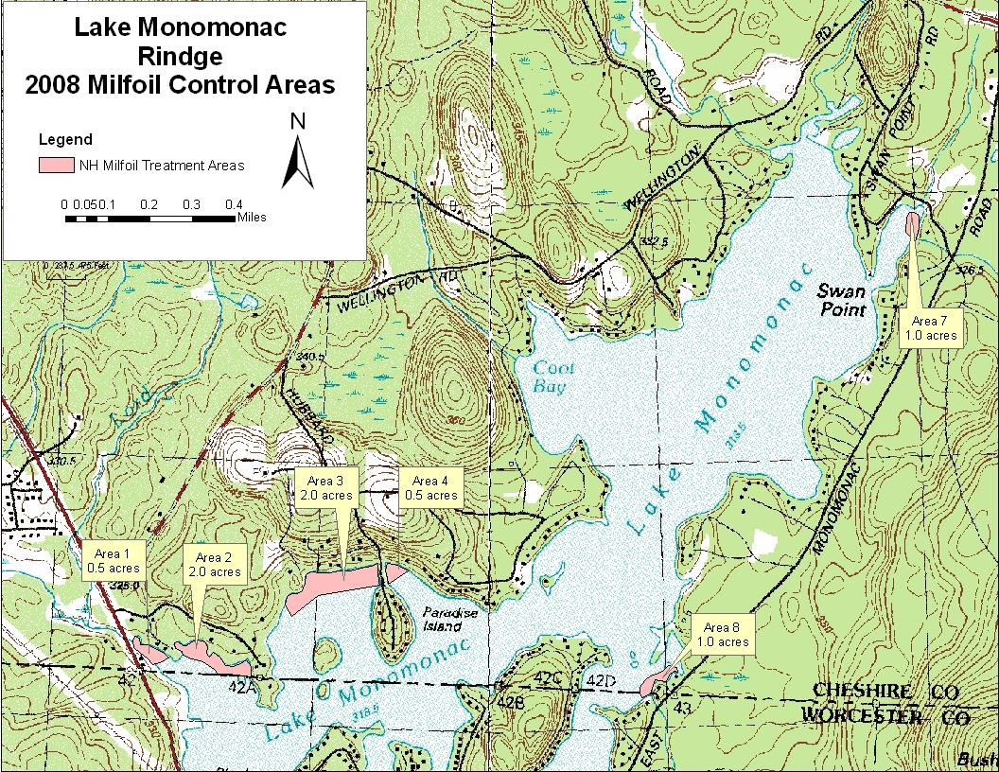

2009
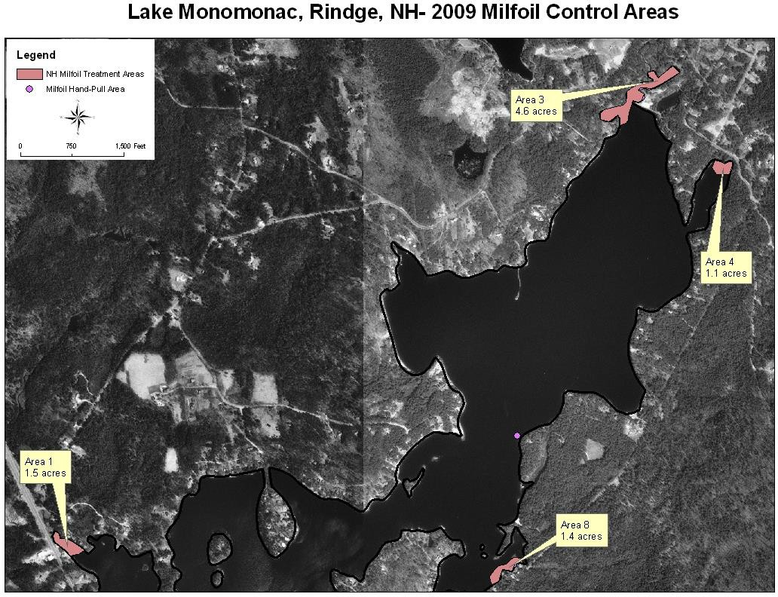

2010
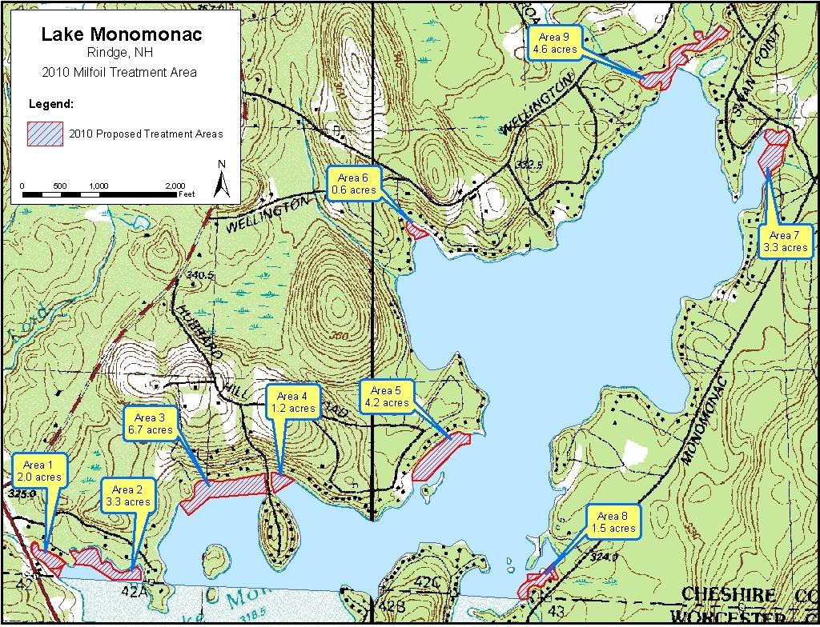

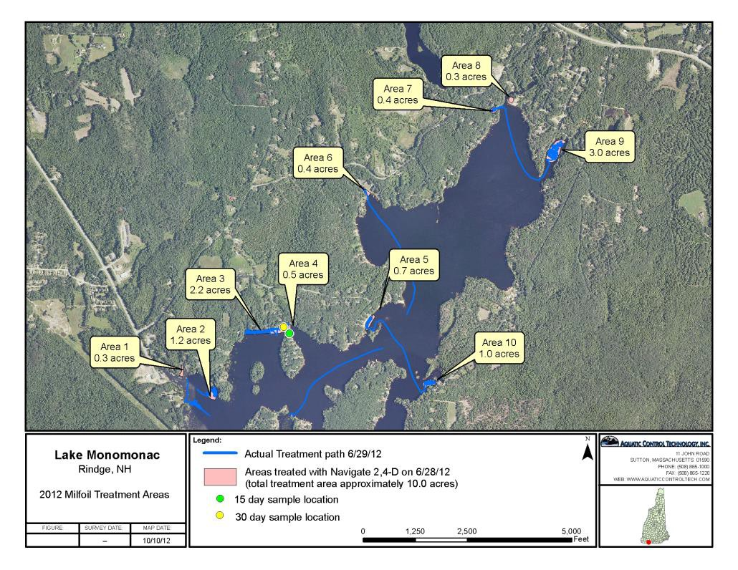
Page 26 of 54

2011
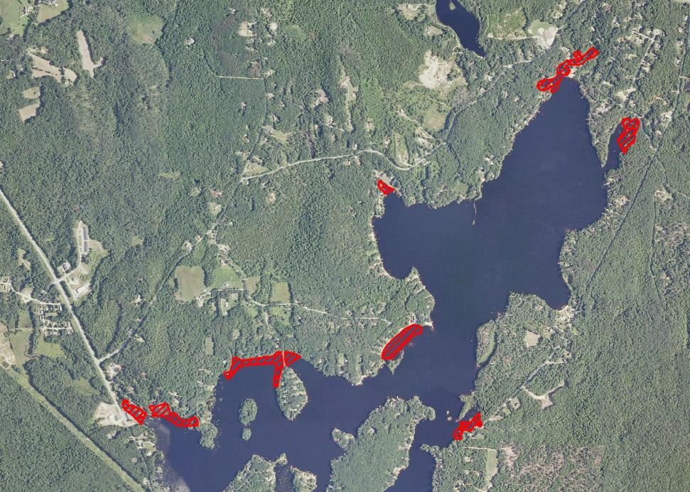

2
0
1
2

2013
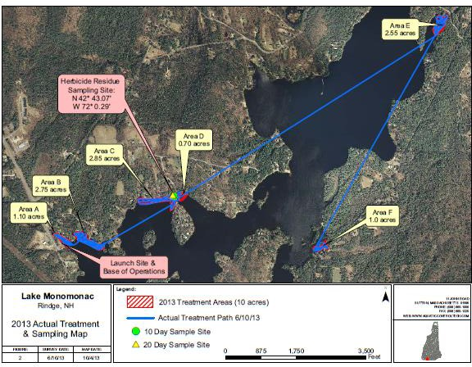

Page 28 of 54

2014 (actual)
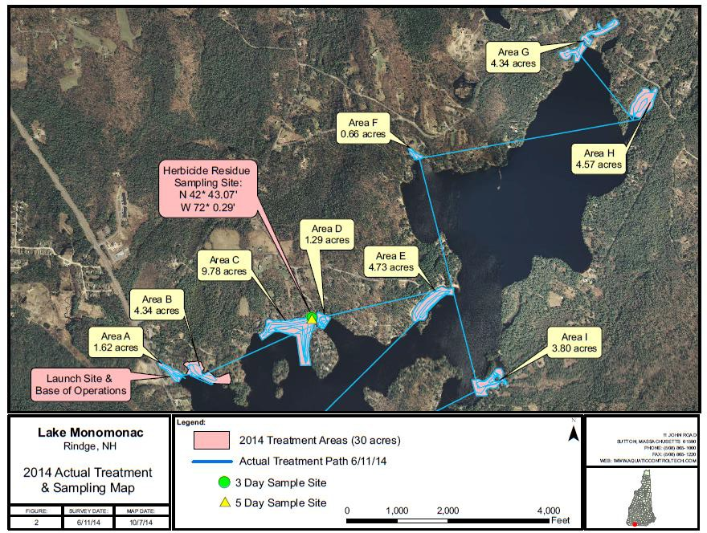

2015 (actual)

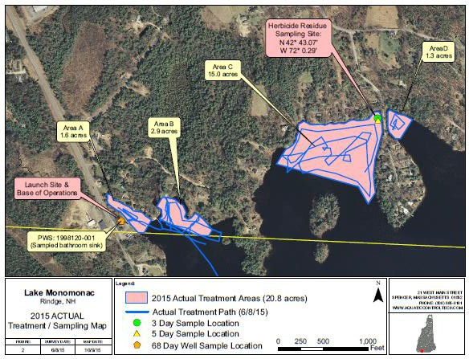

Page 30 of 54

2016 (actual)

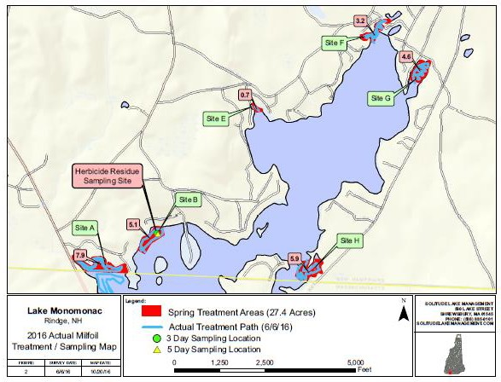

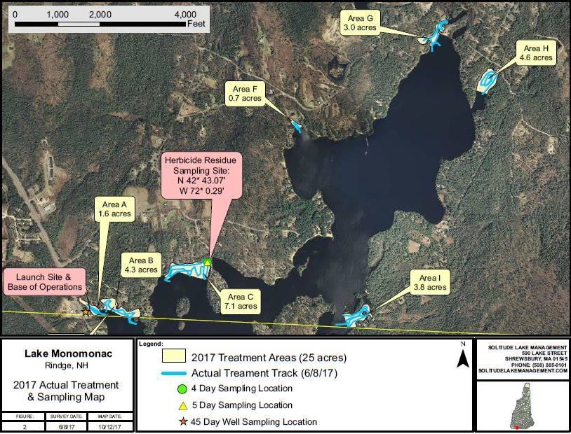
2017 (actual)

Page 32 of 54

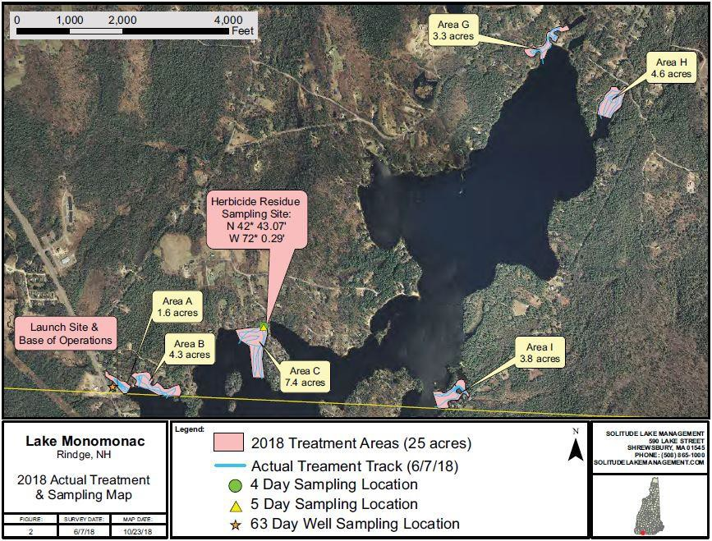
2018 (Actual)

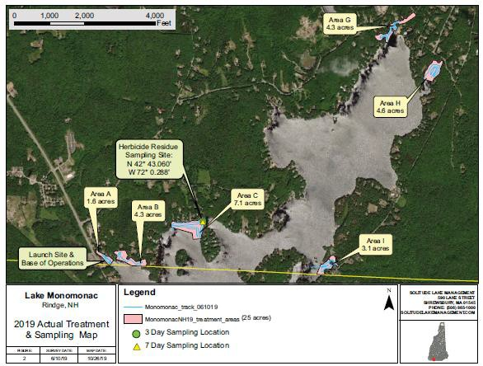
2019 Actual

Page 34 of 54

2020 Actual
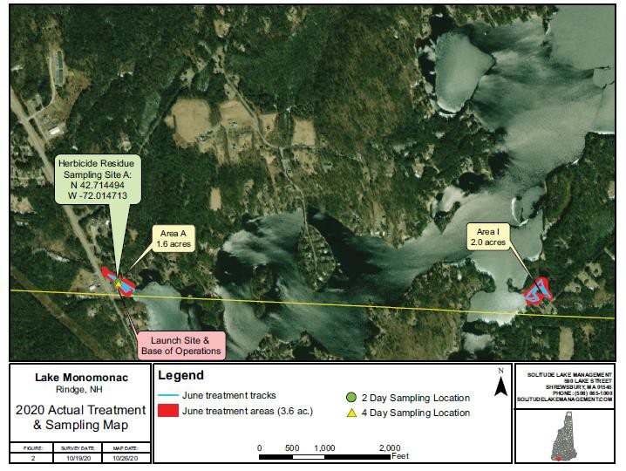

2021 Actual
No control actions performed in 2021 as early season there was no milfoil growth in areas designated/permitted for treatment.

2022 Actual
In addition to the information shown in the map for herbicide treatment, some follow-up diving took place in Area A.
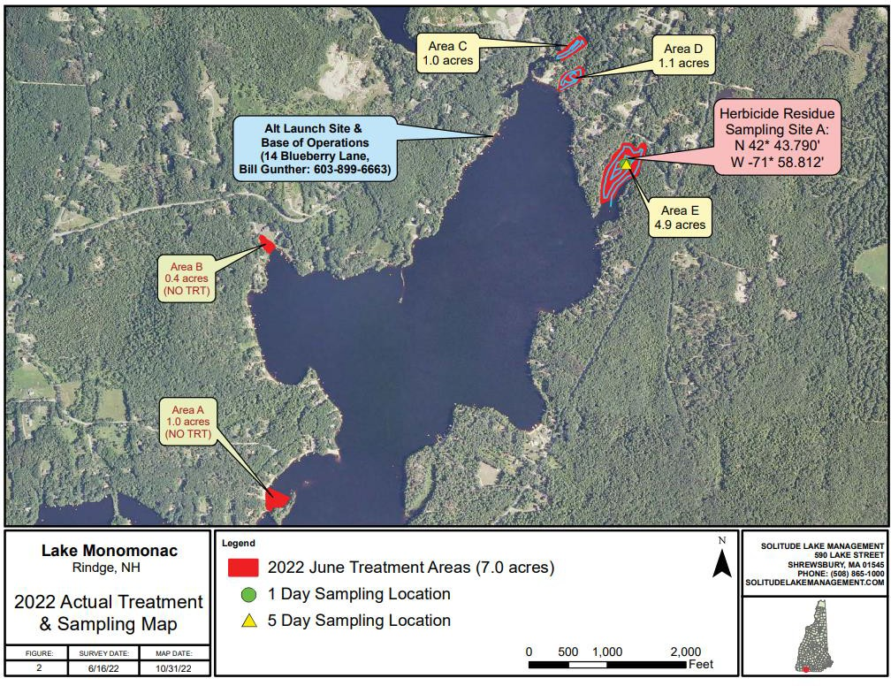

Page 36 of 54

2023 Proposed
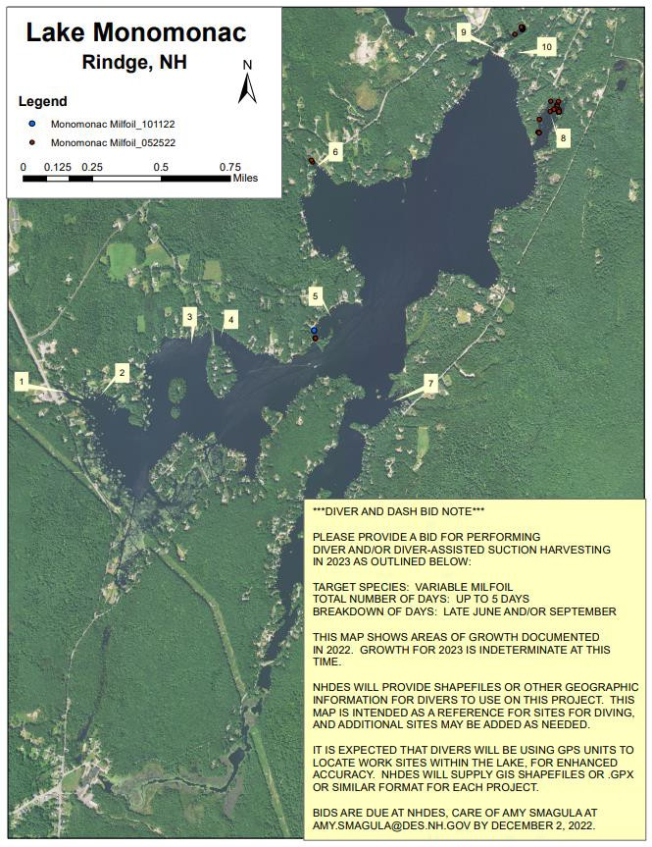

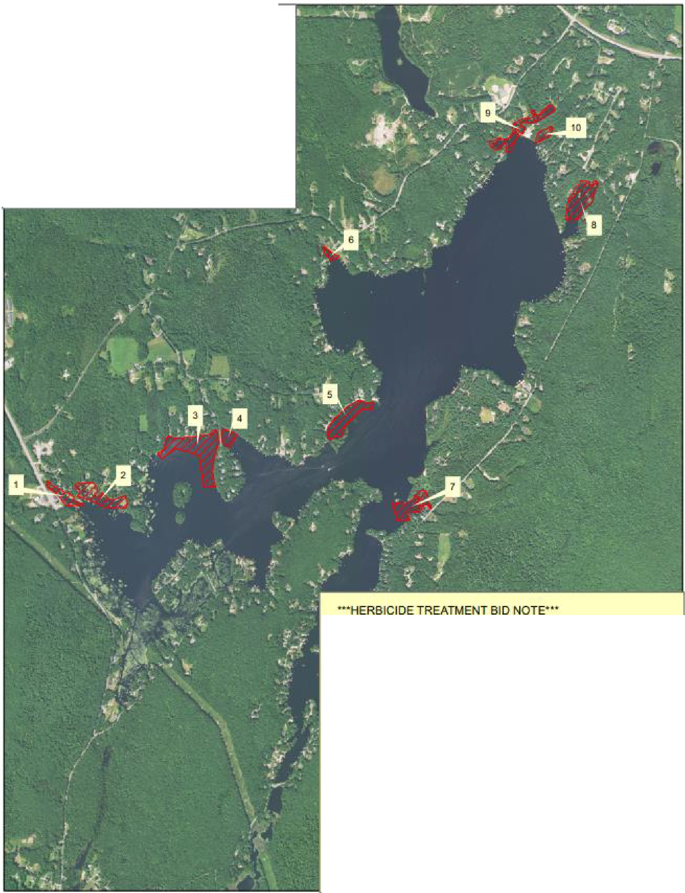
Lake Monomonac
Rindge, .NH N
Legend
A
iz::zj Mooomonac_2023_ ntlal_Trea1moot_Al&a
0 0.125 0.25
- --c==---========i Miles
0.5 0.75
PLEASE PROVIDE A BID FOR PERFORMING
AN HERBICIDE TREATMENT IN 2023 AS DUTI..INED BELOW:

TARGET SPECIES:VARIABLE MllFOIL TREATMENTACRES: UPT025ACRES
MEAN DEPTH OF TREATMENT AREAS: 5 FEET
TREATMENT DETA1l: PROCELLACOR. MID JUNE DR AUGUST

TREATMENT AREAS MAY .BE SMALLER THAN
TI-iE FOOTPRINT SHOWN, AND Wil'l BE FJN,i.LtzEO BASED ON FIELD SURVEYS 3 WEE°KS PRIOR TOTREATh1ENT.

PLEASE PROVIDE ANY ADDITIONAL PRODUCT OPTIONS AND APPLICATION RATES THAT YOU DEEM APPROPRIATE FOR THIS SITE, AS WELL AS A LJNE-HEM BUDGET SHOWING PROJECTED COSTS.

BlOS ARE DUE :AT NHDES, CARE OFAM'j SMAGULA AT AMV:SMAGULA@E>ES.NH.GOV BY DECBMBER 2. 2022.

Page 38 of 54

Figure 3: Map of Native Aquatic Macrophytes

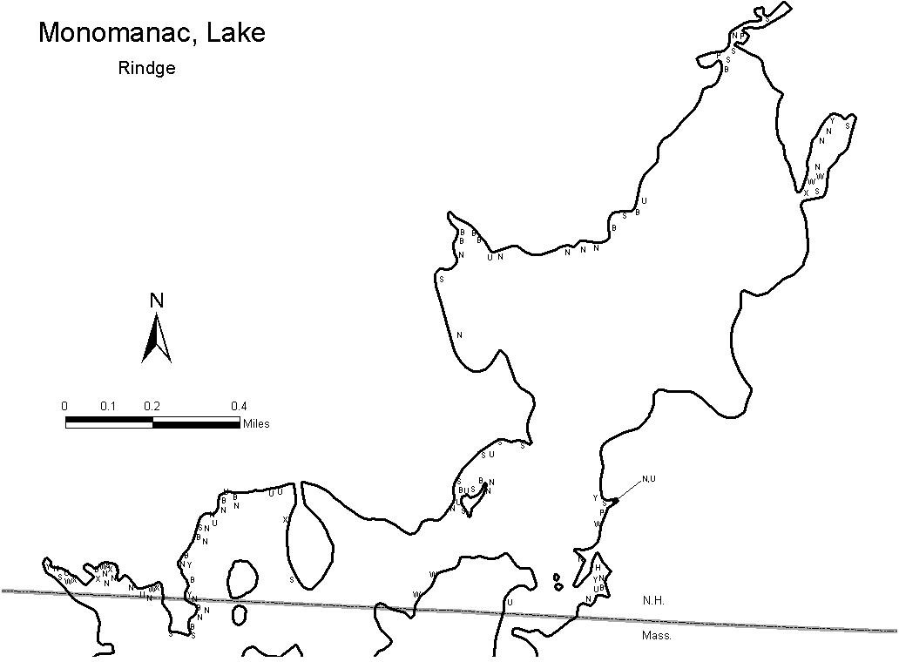

Key to Macrophyte Map
Symbol | Common Name | Latin Name
H | Native milfoil | Myriophyllum humile
d | Three-way sedge | Dulichium
P | Pickerelweed | Pontedaria cordata
T | Cattail | Typha
B | Watershield | Brasenia
N | White water-lily | Nymphaea
Y | Yellow water-lily | Nuphar
S | Bur-reed | Sparganium
U | Bladderwort | Utricularia
X | Sterile thread-like leaves | Eleocharis sp (likely)
W | Pondweed | Potamogeton sp.

Page 40 of 54

Figure 4: Bathymetric Map

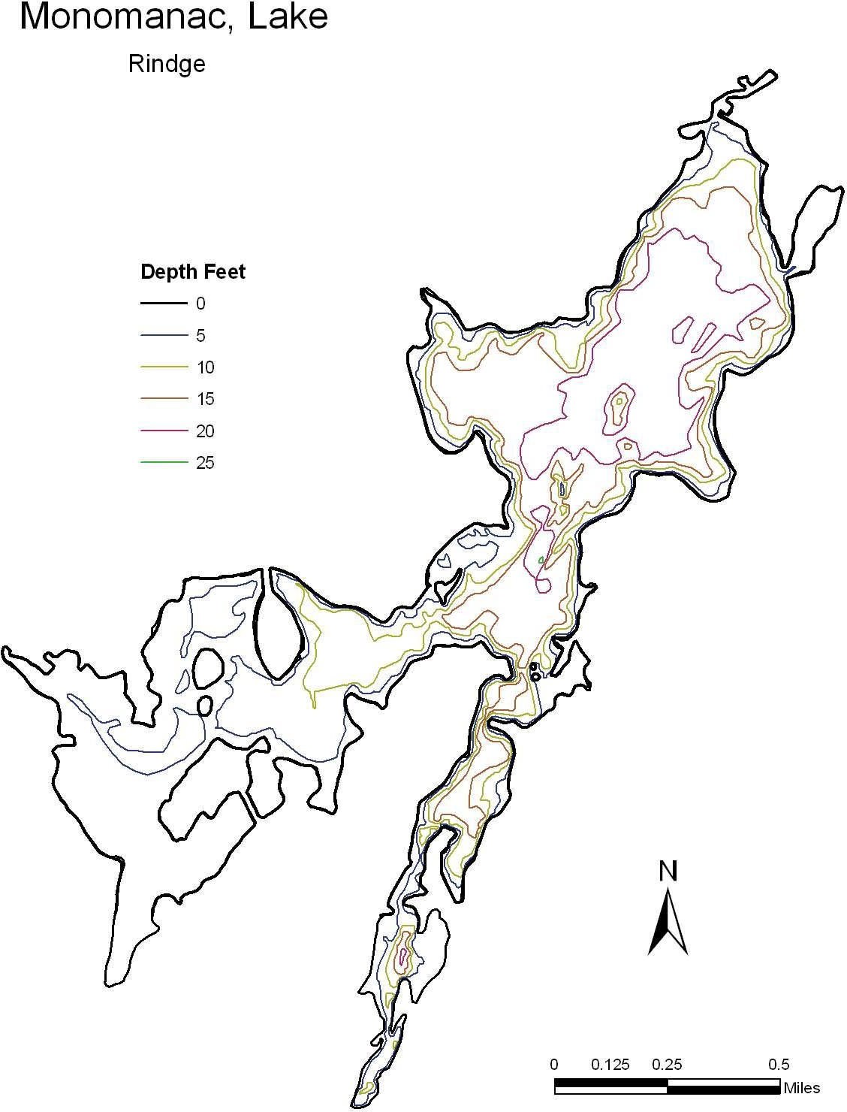

Figure 5: Critical Habitats or Conservation Areas

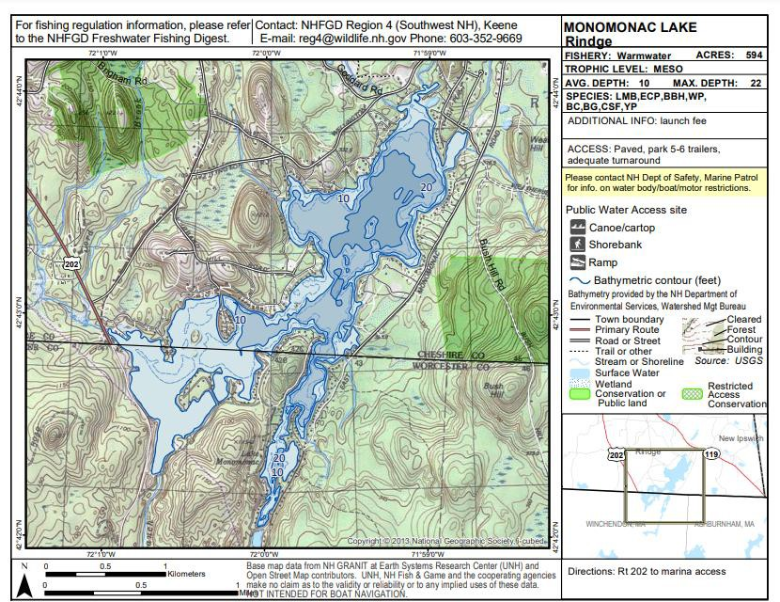

Page 42 of 54

Figure 6: Public Access Sites, Swim Areas, Docks and Swim Platforms

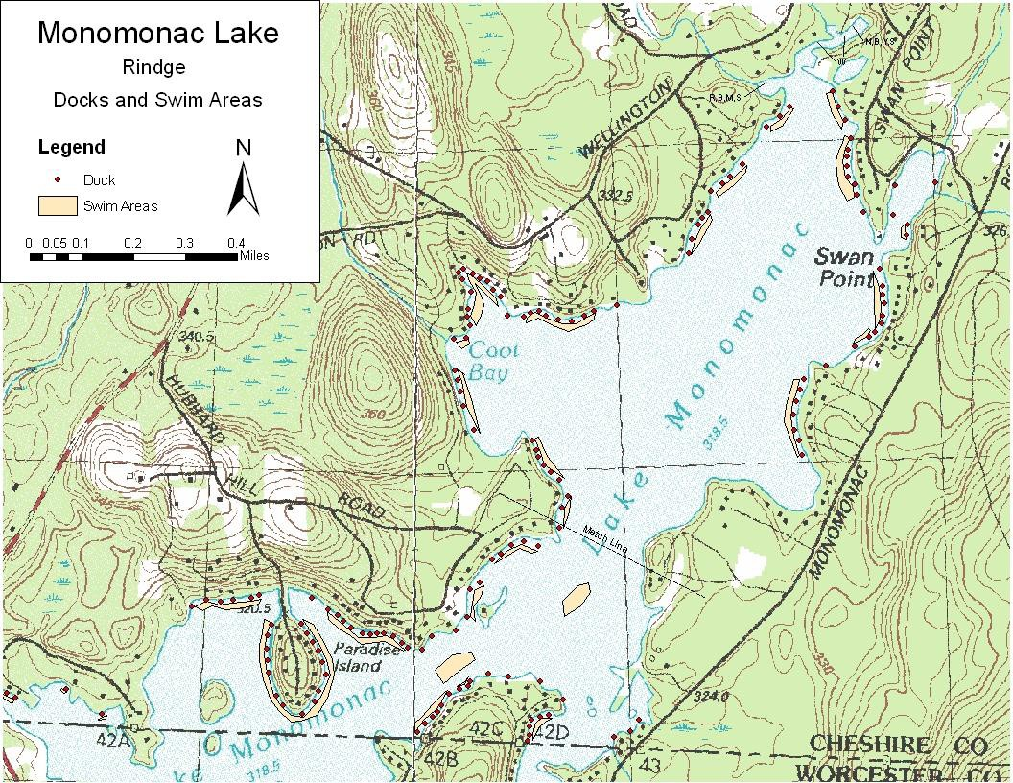

Figure 7: Wells and Water Supplies

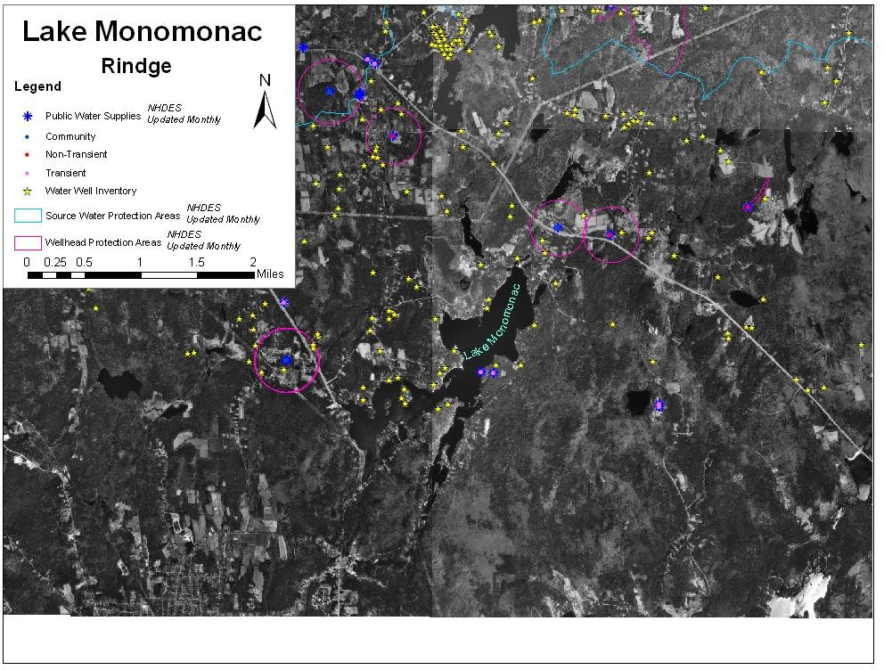

Page 44 of 54

Appendix AAquatic Plant Control Techniques

Preliminary Investigations

Field Site Inspection

  - Verify genus and species of the plant.
  - Determine if the plant is a native or exotic species per RSA 487:16, II.
  - Map extent of the exotic aquatic plant infestation (area, water depth, height of the plant, density of the population).
  - Document any native plant abundances and community structure around and dispersed within the exotic/nuisance plant population (provide updated native plant map after review of milfoil in the Fall or after treatment)

Office/Laboratory Research of Waterbody Characteristics

  - Contact the appropriate agencies to determine the presence of rare or endangered species in the waterbody or its prime wetlands.
  - Determine the basic relevant limnological characteristics of the waterbody (size, bathymetry, flushing rate, nutrient levels, trophic status, and type and extent of adjacent wetlands).
  - Determine the potential threat to downstream waterbodies from the exotic aquatic plant based on limnological characteristics (water chemistry, quantity, quality as they relate to movement or support of exotic plant growth).

Overall Control Options

For any given waterbody that has an infestation of exotic plants, one of four options will be selected, based on the status of the infestation, the available management options, and the technical knowledge of the DES Limnologists and other key resource managers who have conducted the field work and who are preparing or contributing to this plan. The options are as follows:

- Eradication: The goal is to completely remove the exotic plant infestation over time. In some situations this may be a rapid response that results in an eradication event in a single season (such as for a new infestation), in other situations a longer-term approach may be warranted given the age and distribution of the infestation. Eradication is more feasible in smaller systems without extensive expanded growth (for example, Lake Winnipesaukee is unlikely to achieve eradication of its variable milfoil), or without upstream sources of infestation in other connected systems that continually feed the lake.

- Maintenance: Waterbodies where maintenance is specified as a goal are generally those with expansive infestations, that are larger systems, that have complications of extensive wetland complexes on their periphery, or that have upstream sources of the invasive plant precluding the possibility for eradication. For waterbodies where maintenance is the goal, control activities will be performed on the waterbody to keep an infestation below a desirable threshold. For maintenance projects, thresholds of percent cover or other measurable classification will be indicated, and action will occur when exotic plant growth exceeds the threshold.

- Containment: The aim of this approach is to limit the size and extent of the existing infestation within an infested waterbody if it is localized in one portion of that waterbody (such as in a cove or embayment), or if a whole lake is infested action may be taken to prevent the downstream migration of fragments or propagules. This could be achieved through the use of fragment barriers and/or Restricted Use Areas or other such physical means of containment. Other control activities may also be used to reduce the infestation within the containment area.

- No action. If the infestation is too large, spreading too quickly, and past management strategies have proven ineffective at controlling the target exotic aquatic plant, DES, in consultation with others, may elect to recommend ‘no action’ at a particular site. Feasibility of control or control options may be revisited if new information, technologies, etc., develop.

If eradication, maintenance or containment is the recommended option to pursue, the following series of control techniques may be employed. The most appropriate technique(s) based on the determinations of the preliminary investigation will be selected.

Guidelines and requirements of each control practice are suggested and detailed below each alternative, but note that site specific conditions will be factored into the evaluation and recommendation of use on each individual waterbody with an infestation.

Hand-Pulling and Diver-Assisted Suction Harvesting

    - Hand-pulling can be used if infestation is in a small localized area (sparsely populated patch of up to 5’ X 5’, single stems, or dense small patch up to 2’ X 2’). For larger areas Diver-Assisted Suction Harvesting (DASH) may be more appropriate.
    - Can be used if plant density is low, or if target plant is scattered and not dense.

Page 46 of 54

    - Can be used if the plant could effectively be managed or eradicated by hand- pulling or DASH
    - Use must be in compliance with the Wetlands Bureau rules.

Mechanically Harvest or Hydro-Rake

    - Can not be used on plants which reproduce vegetatively by fragmentation (e.g., milfoil, fanwort, etc.) unless containment can be ensured.
    - Can be used only if the waterbody is accessible to machinery.
    - Can be used if there is a disposal location available for harvested plant materials.
    - Can be used if plant depth is conducive to harvesting capabilities (~ <7 ft. for mower, ~ <12 ft. for hydro-rake).
    - If a waterbody is fully infested and no other control options are effective, mechanical harvesting can be used to open navigation channel(s) through dense plant growth.

Herbicide Treatment

    - Can be used if application of herbicide is conducted in areas where alternative control techniques are not optimum due to depth, current, use, or density and type of plant.
    - Can be used for treatment of exotic plants where fragmentation is a high concern.
    - Can be used where species specific treatment is necessary due to the need to manage other plants
    - Can be used if other methods used as first choices in the past have not been effective.
    - A licensed applicator should be contacted to inspect the site and make recommendations about the effectiveness of herbicide treatment as compared with other treatments.

Restricted Use Areas (per RSA 487:17, II (d))

    - Can be established in an area that effectively restricts use to a small cove, bay, or other such area where navigation, fishing, and other transient activities may cause fragmentation to occur.
    - Can not be used when there are several “patches” of an infestation of exotic
aquatic plants throughout a waterbody.
    - Can be used as a temporary means of control.

Bottom Barrier
    - Can be used in small areas, preferably less than 10,000 sq. ft.
    - Can be used in an area where the current is not likely to cause the displacement of the barrier.
    - Can be used early in the season before the plant reaches the surface of the water.
    - Can be used in an area to compress plants to allow for clear passage of boat traffic.
    - Can be used in an area to compress plants to allow for a clear swimming area.
    - Use must be in compliance with the Wetlands Bureau rules.

Drawdown

    - Can be used if the target plant(s) are susceptible to drawdown control.
    - Can be used in an area where bathymetry of the waterbody would be conducive to an adequate level of drawdown to control plant growth, but where extensive deep habits exist for the maintenance of aquatic life such as fish and amphibians.
    - Can be used where plants are growing exclusively in shallow waters where a drawdown would leave this area “in the dry” for a suitable period of time (over winter months) to control plant growth.
    - Can be used in winter months to avoid encroachment of terrestrial plants into the aquatic system.
    - Can be used if it will not significantly impact adjacent or downstream wetland habitats.
    - Can be used if spring recharge is sufficient to refill the lake in the spring.
    - Can be used in an area where shallow wells would not be significantly impacted.
    - Reference RSA 211:11 with regards to drawdown statutes.

Dredge

    - Can be used in conjunction with a scheduled drawdown.
    - Can be used if a drawdown is not scheduled, though a hydraulic pumping dredge should be used.
    - Can only be used as a last alternative due to the detrimental impacts to environmental and aesthetic values of the waterbody.

Biological Control

    - Grass carp cannot be used as they are illegal in New Hampshire.
    - Exotic controls, such as insects, cannot be introduced to control a nuisance plant unless approved by Department of Agriculture.

Page 48 of 54

    - Research should be conducted on a potential biological control prior to use to determine the extent of target specificity.

Appendix B Control Practices Used in New Hampshire

Restricted Use Areas and Fragment Barrier:
Restricted Use Areas (RUAs) are a tool that can be use to quarantine a portion of a waterbody if an infestation of exotic aquatic plants is isolated to a small cove, embayment, or section of a waterbody. RUAs generally consist of a series of buoys and ropes or nets connecting the buoys to establish an enclosure (or exclosure) to protect an infested area from disturbance. RUAs can be used to prevent access to these infested areas while control practices are being done, and provide the benefit of restricting boating, fishing, and other recreational activities within these areas, so as to prevent fragmentation and spread of the plants outside of the RUA.

Hand-pulling:
Hand-pulling exotic aquatic plants is a technique used on both new and existing infestations, as circumstances allow. For this technique divers carefully hand-remove the shoots and roots of plants from infested areas and place the plant material in mesh dive bags for collect and disposal. This technique is suited to small patches or areas of low density exotic plant coverage.

For a new infestation, hand-pulling activities are typically conducted several times during the first season, with follow-up inspections for the next 1-2 years or until no re-growth is observed. For existing infestations, hand-pulling may be done to slow the expansion of plant establishment in a new area or where new stems are removed in a section that may have previously been uninfested. It is often a follow-up technique that is included in most management plans.

In 2007 a new program was created through a cooperative between a volunteer monitor that is a certified dive instructor, and the DES Exotic Species Program. A Weed Control Diver Course (WCD) was developed and approved through the Professional Association of Dive Instructors (PADI) to expand the number of certified divers available to assist with hand-pulling activities. DES has only four certified divers in the Limnology Center to handle problems with aquatic plants, and more help was needed. There is a unique skill involved with hand-removing plants from the lake bottom. If the process is not conducted correctly, fragments could spread to other waterbody locations. For this reason, training and certification are needed to help ensure success. Roughly 100 divers were certified through this program through the 2010 season. DES maintains a list of WCD divers and shares them with waterbody

Page 50 of 54

groups and municipalities that seek diver assistance for controlling exotic aquatic plants. Classes are offered two to three times per summer.

Diver Assisted Suction Harvesting
Diver Assisted Suction Harvesting (DASH) is an emerging and evolving control technique in New Hampshire. The technique employs divers that perform hand removal actions as described above, however, instead of using a dive bag a mechanical suction device is used to entrain the plants and bring them topside where a tender accumulates and bags the material for disposal. Because of this variation divers are able to work in moderately dense stands of plants that cover more bottom area, with increased efficiency and accuracy.

Mechanical Harvesting
The process of mechanical harvesting is conducted by using machines which cut and collect aquatic plants. These machines can cut the plants up to twelve feet below the water surface. The weeds are cut and then collected by the harvester or other separate conveyer-belt driven device where they are stored in the harvester or barge, and then transferred to an upland site.

The advantages of this type of weed control are that cutting and harvesting immediately opens an area such as boat lanes, and it removes the upper portion of the plants. Due to the size of the equipment, mechanical harvesting is limited to water areas of sufficient size and depth. It is important to remember that mechanical harvesting can leave plant fragments in the water, which if not collected, may spread the plant to new areas. Additionally harvesters may impact fish and insect populations in the area by removing them in harvested material. Cutting plant stems too close to the bottom can result in re-suspension of bottom sediments and nutrients. This management option is only recommended when nearly the entire waterbody is infested, and harvesting is needed to open navigation channels through the infested areas.

Benthic Barriers:
Benthic barriers are fiberglass coated screening material that can be applied directly to the lake bottom to cover and compress aquatic plant growth. Screening is staked or weighted to the bottom to prevent it from becoming buoyant or drifting with current. The barriers also serve to block sunlight and prevent photosynthesis by the plants, thereby killing the plants with time. While a reliable method for small areas of plants (roughly 100 sq. ft. or less), larger areas are not reasonably controlled with this method due to a variety of factors (labor intensive installation, cost, and gas accumulation and bubbling beneath the barrier).

Targeted Application of Herbicides
Application of aquatic herbicides is another tool employed for controlling exotic aquatic plants. Generally, herbicides are used when infestations are too large to be controlled using other alternative non-chemical controls, or if other techniques have been tried and have proven unsuccessful. Each aquatic plant responds differently to different herbicides and concentrations of herbicides, but research performed by the Army Corps of Engineers has isolated target specificity of a variety of aquatic herbicides for different species.

Generally, 2,4-D (Navigate formulation) is the herbicide that is recommended for control of variable milfoil. Based on laboratory data this is the most effective herbicide in selectively controlling variable milfoil in New
Hampshire’s waterbodies.

A field trial was performed during the 2008 summer using the herbicide Renovate to control variable milfoil. Renovate is a systemic aquatic herbicide that targets both the shoots and the roots of the target plant for complete control. In this application it was dispersed as a granular formulation that sank quickly to the bottom to areas of active uptake of the milfoil plants. A small (<5 acre) area of Captains Pond in Salem was treated with this systemic herbicide. The herbicide was applied in pellet form to the infested area in May 2008, and showed good control by the end of the growing season. Renovate works a little more slowly to control aquatic plants than 2,4-D and it is a little more expensive, but presents DES with another alternative that could be used in future treatments.

During the summer of 2010, DES worked with other researchers to perform field trials of three different formulations of 2,4-D in Lake Winnisquam, to determine which product was most target-specific to the variable milfoil.

Page 52 of 54

Navigate formulation was used, as were a 2,4-D amine formulation, and a 2,4- D amine and triclopyr formulation (MaxG). Although the final report has not been completed for this study, preliminary results suggest that all three products worked well, but that Navigate formation may be the most target specific of all three.

Another herbicide, Fluridone, is sometimes also used in New Hampshire, mainly to control growths of fanwort (Cabomba caroliniana). Fluridone is a systemic aquatic herbicide that inhibits the formation of carotenoids in plants. Reduced carotenoids pigment ultimately results in the breakdown of chlorophyll and subsequent loss of photosynthetic function of the plants.

Other aquatic herbicides are also used in New Hampshire when appropriate (glyphosate, copper compounds, etc). The product of choice will be recommended based on what the target species is, and other waterbody- specific characteristics that are important to consider when selecting a product.

In 2018, a new aquatic formulation of an herbicide was labeled and licensed for use. ProcellaCOR is a reduced-risk liquid formulation herbicide that is a systemic. Based on New Hampshire field data, it works well on variable milfoil, it is taken up very quickly following treatment (hours) and it degrades quickly in the water column, with typical non-detect readings within 24-48 hours post treatment.

Extended Drawdown
Extended drawdown serves to expose submersed aquatic plants to dessication and scouring from ice (if in winter), physically breaking down plant tissue. Some species can respond well to drawdown and plant density can be reduced, but for invasive species drawdown tends to yield more disturbance to bottom sediments, something to which exotic plants are most adapted. In waterbodies where drawdown is conducted exotic plants can often outcompete native plants for habitat and come to dominate the system.

Some waterbodies that are heavily infested with exotic plants do conduct drawdowns to reduce some of the invasive aquatic plant density. During this reporting period both Northwood Lake (Northwood) and Jones Pond (New Durham) coordinated deep winter drawdowns to reduce growths of variable milfoil (the drawdown on Northwood Lake is primarily for flood control purposes, but they do see some ancillary benefits from the technique for variable milfoil control), however it is variable from year to year, and not a

reliable control technique. In some cases, some plants like milfoils can form succulent emergent forms of growth, that can resist drawdown.

Drawdown is not a target-specific control technique. Other forms of aquatic life, including native plants, mussels, insects, fish and other organisms can be affected by drawdown. Further, exposure of lake sediments can alter nutrient cycling regimes, leading to variations in algal growth, including potentially harmful cyanobacteria blooms.

Lake Monomonac has a history of annual drawdowns, and while they may be helpful to a degree for flood control purposes during spring snow melt, they could be a detriment to overall water quality in the lake, as a result of impacts outlined above.

Dredging
Dredging is a means of physical removal of aquatic plants from the bottom sediments using a floating or land-based dredge. Dredging can create a variety of depth gradients creating multiple plant environments allowing for greater diversity in lakes plant, fish, and wildlife communities. However due to the cost, potential environmental effects, and the problem of sediment disposal, dredging is rarely used for control of aquatic vegetation alone.

Dredging can take place in to fashion, including drawdown followed by mechanical dredging using an excavator, or using a diver-operated suction dredge while the water level remains up.

Biological Control
There are no approved biological controls for submersed exotic aquatic plant at this time in New Hampshire.

Page 54 of 54

References

Department of Environmental Services. 2006: 2006 Section 305(b) and 303(d) Consolidated Assessment and Listing Methodology. November 2005. New Hampshire Department of Environmental Services. NHDES-R-WD-05-
29. Available at http://des.nh.gov/WMB/swqa/calm.html

Halstead, J.M., J. Michaud, S. Hallas-Burt, and J.P. Gibbs. 2003. “An Hedonic Analysis of Effects of a Nonative Invader (Myriophyllum heterophyllum) on New Hampshire (USA) Lakefront Properties.” Environmental Management. 32 (3): 391 – 398

Luken, J.O. and J.W. Thieret. 1997. Assessment and Management of Plant Invasions. Springer-Verlag, New York. 324 pages.

